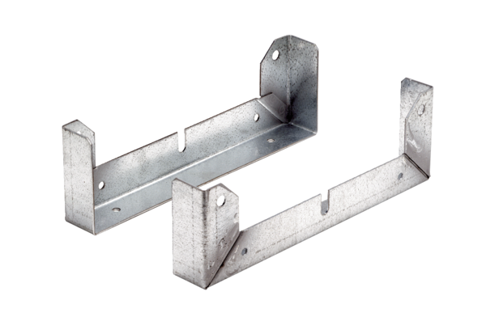Mounting foot FU 30Packing unit: 2 piecesRange: C
Article number: 0036.0071Manufacturer: MAICO

