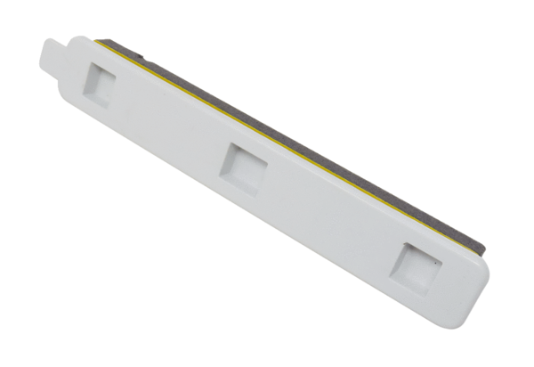Filter locking cover FA F7 WS 75Range: K
Article number: E175.0331.0000Manufacturer: MAICO

