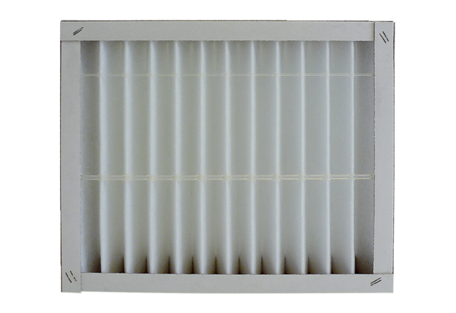Air filter, replacement ECR 12-20 G4Packing unit: 1 pieceRange: C
Article number: 0093.0893Manufacturer: MAICO

