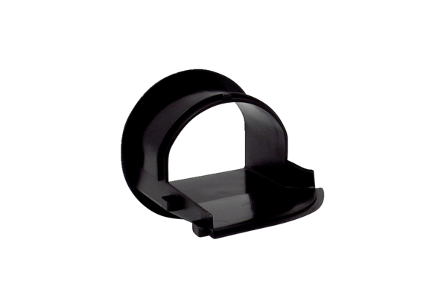Air outlet element AES ER ECRange: B
Article number: E059.2053.0000Manufacturer: MAICO

