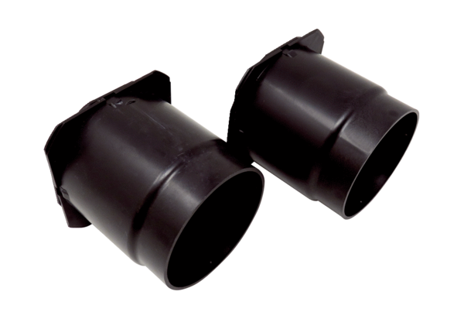Backflow preventer set WS 75 RK-SetPacking unit: 1 set (2 pieces)Range: K
Article number: 0093.1587Manufacturer: MAICO

