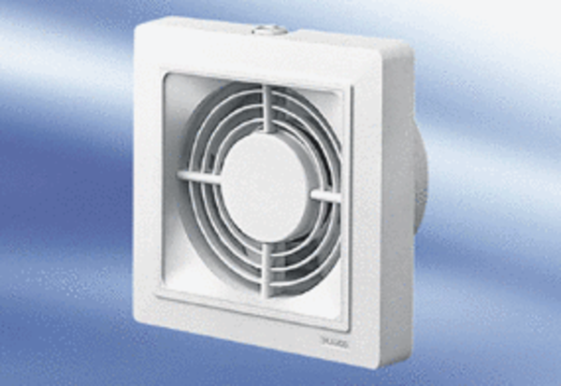Small room fan ECA 15/2 FPacking unit: 1 pieceRange:
Article number: 0080.0976Manufacturer: MAICO

