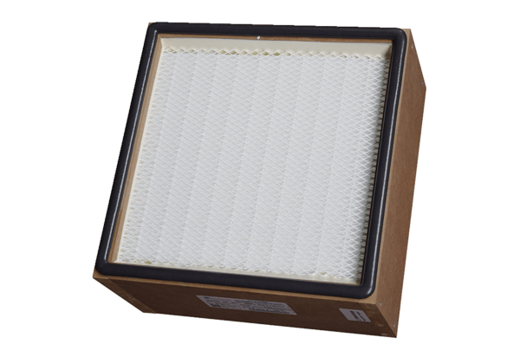Air filter, replacement CB 300 H14Packing unit: 1 pieceRange: L
Article number: 0092.0582Manufacturer: MAICO

