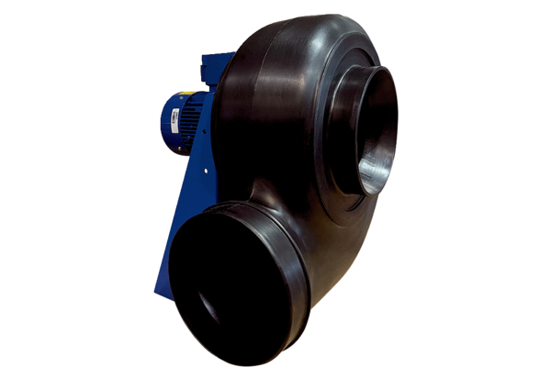Centrifugal blower GRK R 45/4 D ExPacking unit: 1 pieceRange: C
Article number: 0073.0454Manufacturer: MAICO

