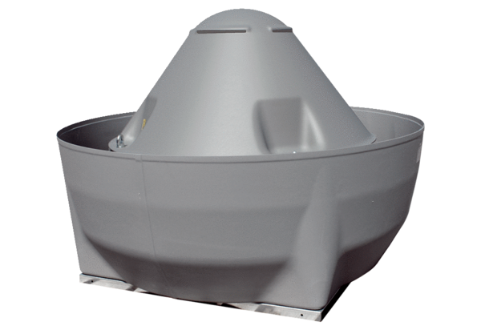Centrifugal roof fan DRD V 90/6Packing unit: 1 pieceRange: C
Article number: 0073.0073Manufacturer: MAICO

