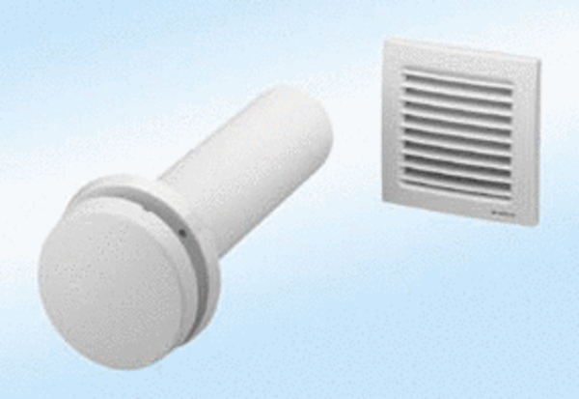Supply air element, uncontrolled ZE10-ITPacking unit: 1 pieceRange: D
Article number: 0152.0036Manufacturer: MAICO

