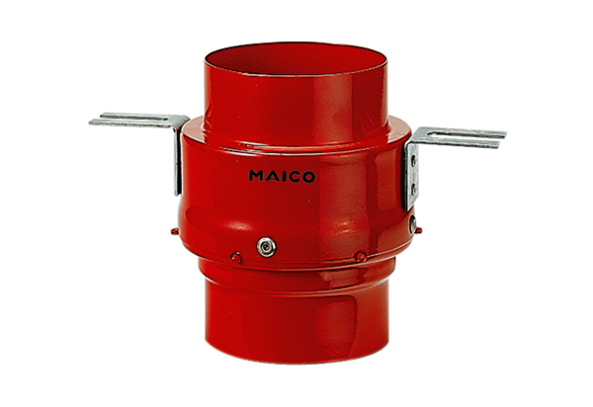Fire protection ceiling barrier TS 18 DN 180Packing unit: 1 pieceRange: B
Article number: 0151.0324Manufacturer: MAICO

