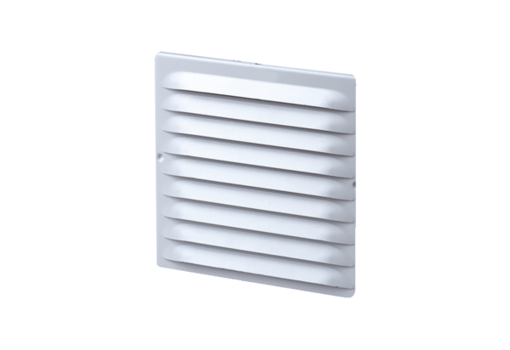External grille MGE 80/125 aluPacking unit: 1 pieceRange: K
Article number: 0078.0030Manufacturer: MAICO

