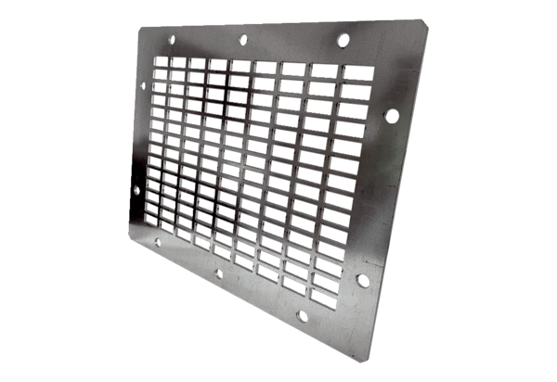Air outlet grille SGAI GR 31Packing unit: 1 pieceRange: C
Article number: 0073.0429Manufacturer: MAICO

