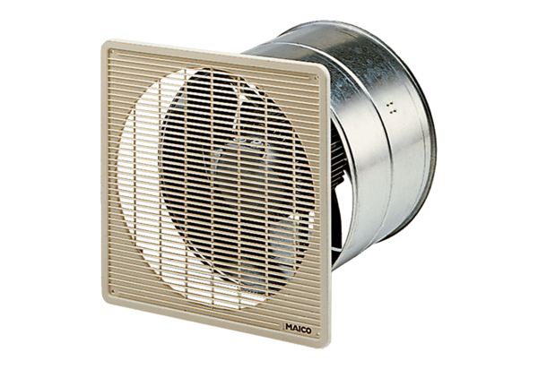EZF 50/8 BPacking unit: 1 pieceRange: C
Article number: 0085.0061Manufacturer: MAICO

