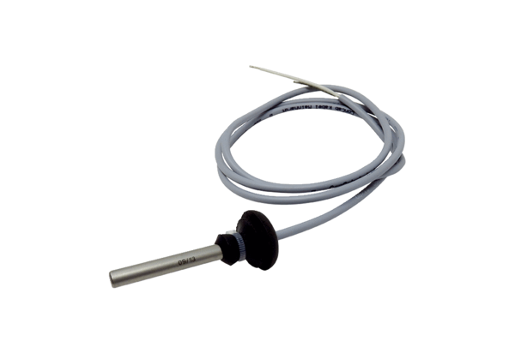Temperature sensor TF WSRB 1Range: K
Article number: E157.0976.9001Manufacturer: MAICO

