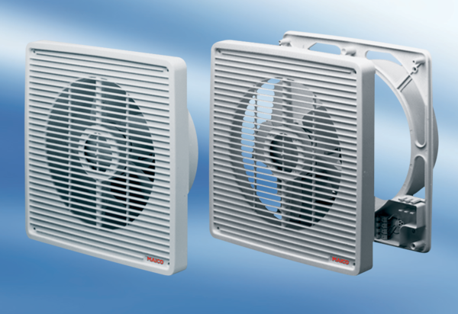Wall-mounted fan ET 25Packing unit: 1 pieceRange: C
Article number: 0081.0502Manufacturer: MAICO

