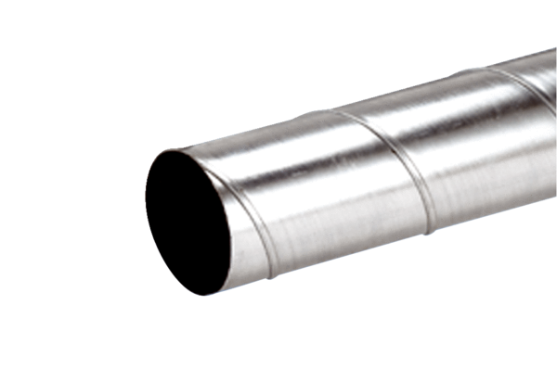Folded spiral-seams duct WFR 125Packing unit: 1 pieceRange: K
Article number: 0055.0077Manufacturer: MAICO

