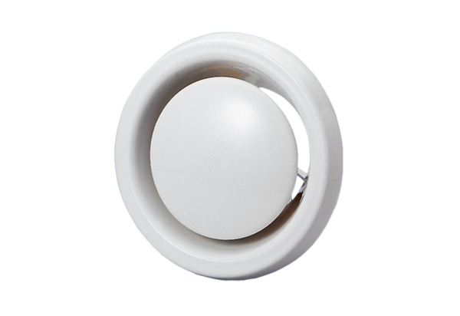Disk valve, fire protection TB 10Packing unit: 1 pieceRange: C
Article number: 0151.0270Manufacturer: MAICO

