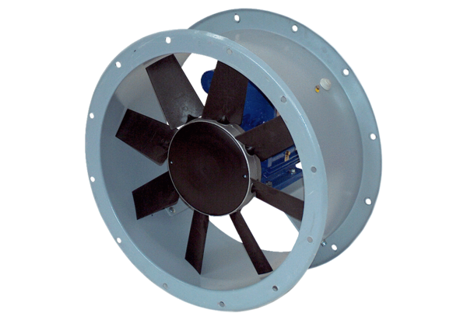Axial duct fan DAR 71/6 0,37Packing unit: 1 pieceRange: C
Article number: 0073.0132Manufacturer: MAICO

