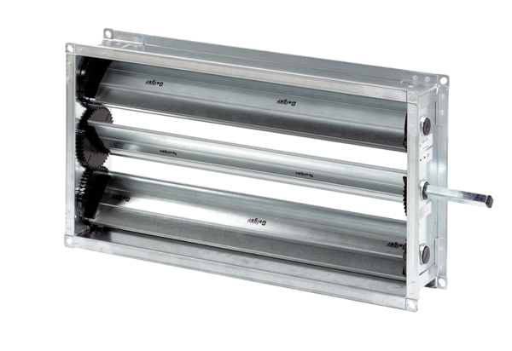Channel shutter RKP 50Packing unit: 1 pieceRange: D
Article number: 0151.0240Manufacturer: MAICO

