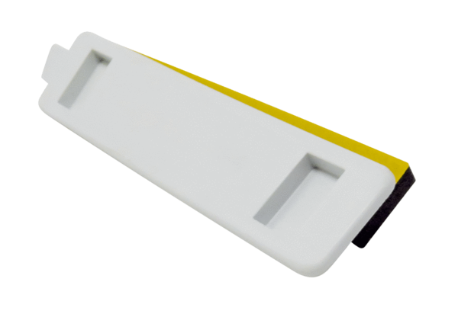Supplementary heat register cover NHA WS 75Range: K
Article number: E175.0332.0000Manufacturer: MAICO

