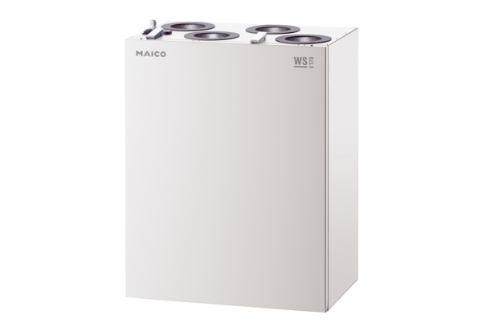Centralised ventilation unit WS 170 LPacking unit: 1 pieceRange: K
Article number: 0095.0278Manufacturer: MAICO

