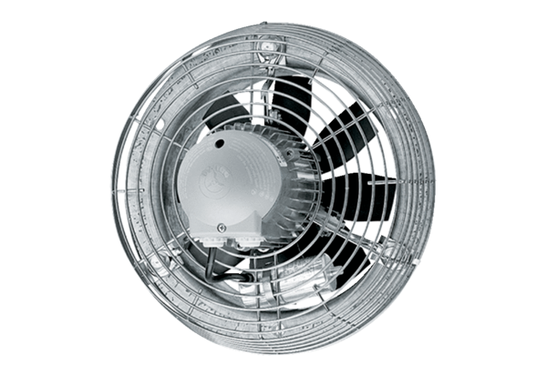Axial wall fan DZS 50/86 BPacking unit: 1 pieceRange: C
Article number: 0094.0067Manufacturer: MAICO

