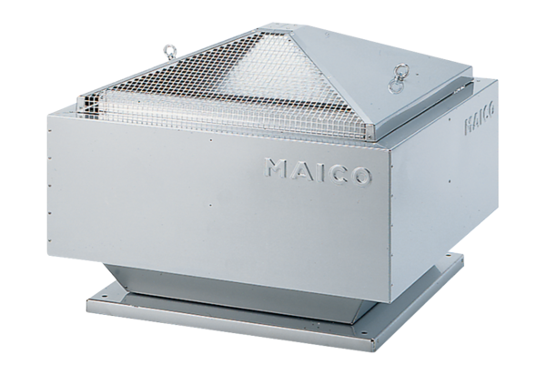Centrifugal roof fan MDR-PG 18 ECPacking unit: 1 pieceRange: E
Article number: 0087.0031Manufacturer: MAICO

