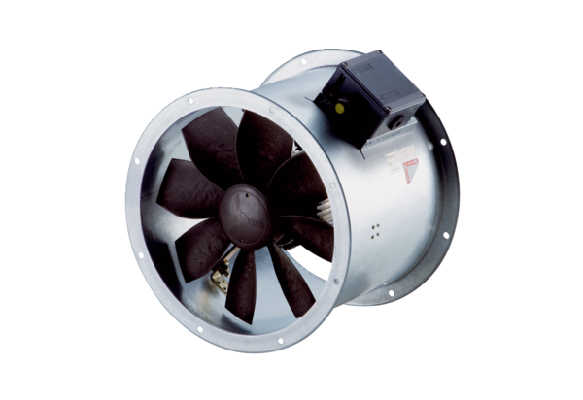Axial duct fan DZR 40/6 B Ex ePacking unit: 1 pieceRange: C
Article number: 0086.0709Manufacturer: MAICO

