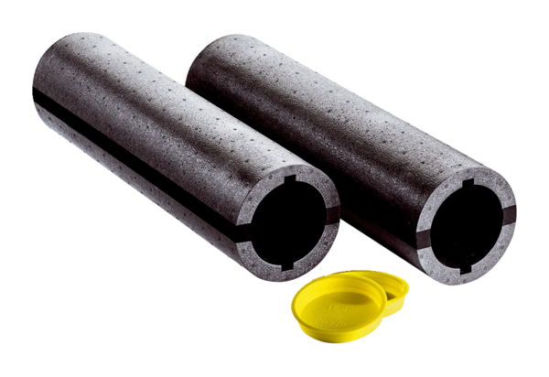Wall sleeve WW90Packing unit: 1 set (2 pieces)Range: K
Article number: 0095.0664Manufacturer: MAICO

