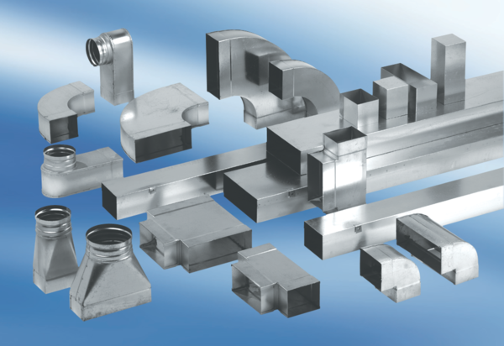40 mm channel sound absorbers with attenuating linging. KSD80/100/1200Packing unit: 1 pieceRange: K
Article number: 0092.0460Manufacturer: MAICO

