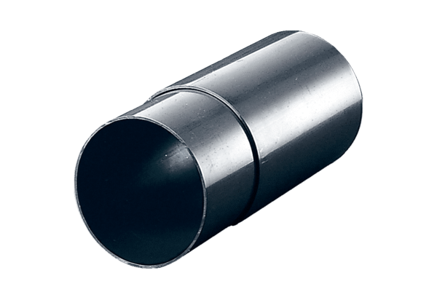Wall sleeve WH 120Packing unit: 1 pieceRange: A
Article number: 0059.1031Manufacturer: MAICO

