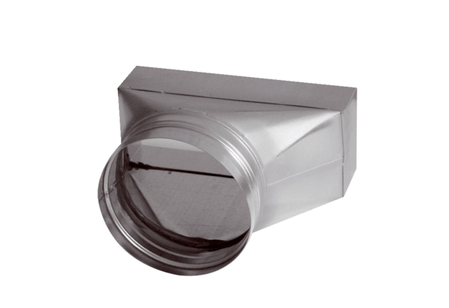Intermediate piece, asymmetric USAN70/170/125Packing unit: 1 pieceRange: K
Article number: 0055.0664Manufacturer: MAICO

