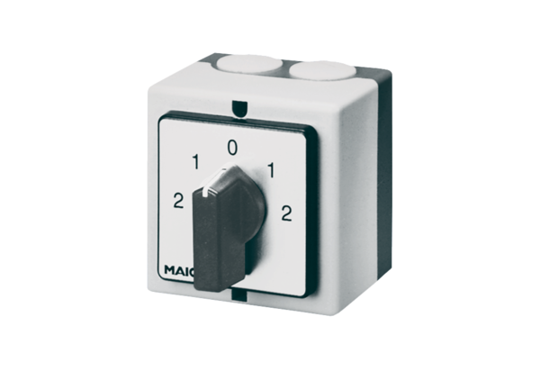Reversing switch, pole-changing switch WP 2Packing unit: 1 pieceRange: C
Article number: 0157.0108Manufacturer: MAICO

