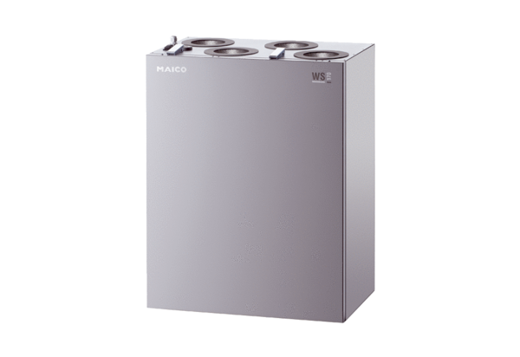Centralised ventilation unit WS 170 KBLPacking unit: 1 pieceRange: K
Article number: 0095.0086Manufacturer: MAICO

