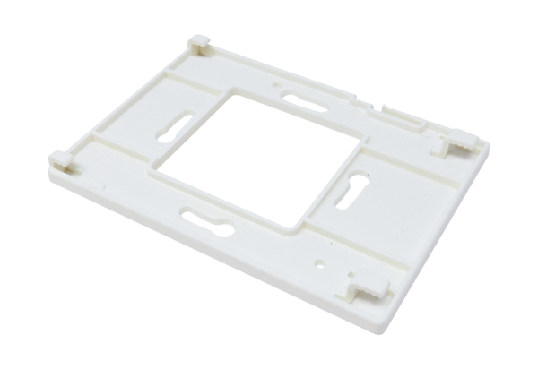Mounting plate for room air control MP RLS WS 75Range: K
Article number: E059.2078.0000Manufacturer: MAICO

