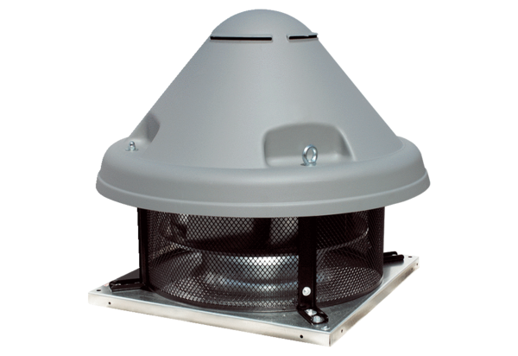Centrifugal roof fan DRD H 35/4 ExPacking unit: 1 pieceRange: C
Article number: 0073.0535Manufacturer: MAICO

