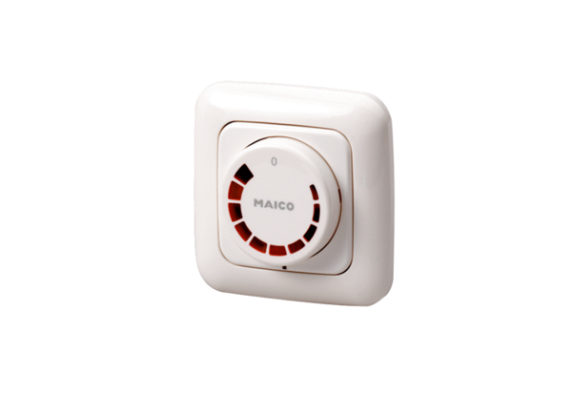Speed controller STU 2,5Packing unit: 1 pieceRange: C
Article number: 0157.0815Manufacturer: MAICO

