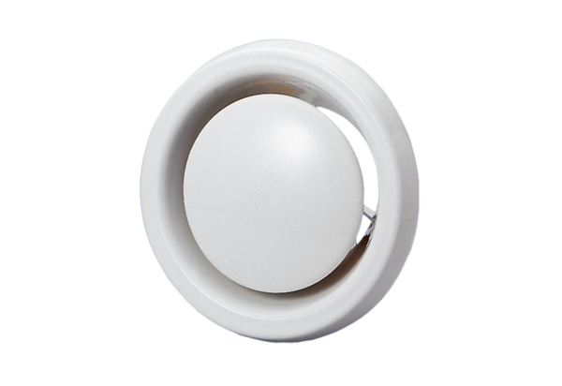Disk valve, fire protection TB 15Packing unit: 1 pieceRange: C
Article number: 0151.0272Manufacturer: MAICO

