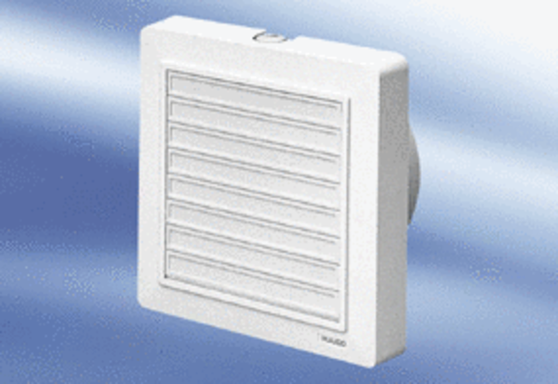Small room fan ECA 15/2 KVZPacking unit: 1 pieceRange:
Article number: 0080.0982Manufacturer: MAICO

