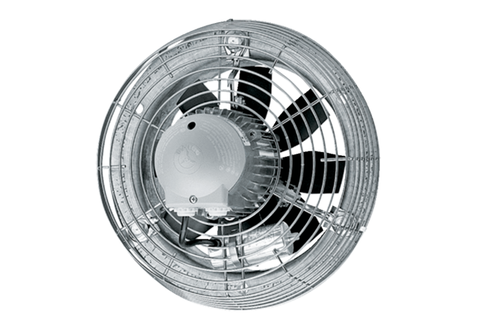Axial wall fan DZS 50/126 BPacking unit: 1 pieceRange: C
Article number: 0094.0052Manufacturer: MAICO

