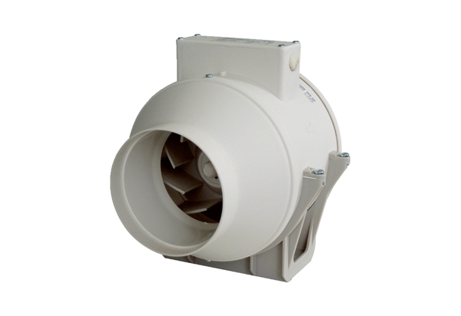Diagonal fan ERK 100Packing unit: 1 pieceRange: C
Article number: 0080.0173Manufacturer: MAICO

