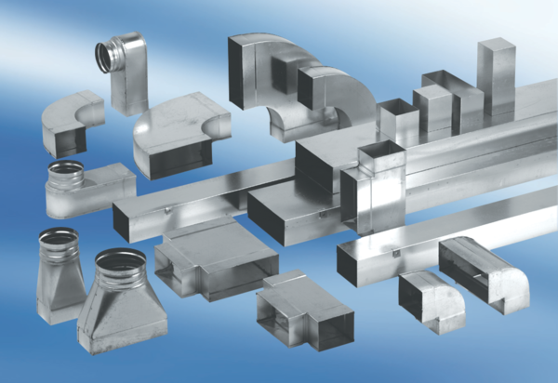Reducer, symmetrical REDS55/220/80Packing unit: 1 pieceRange: K
Article number: 0055.0694Manufacturer: MAICO

