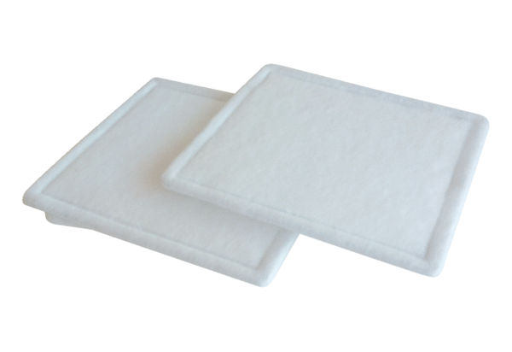Air filter, replacement RF 35-4Packing unit: 2 piecesRange: C
Article number: 0093.0162Manufacturer: MAICO

