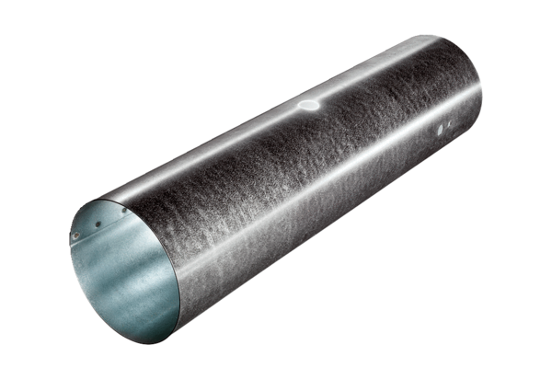Duct piece for servomotor MSR 125Packing unit: 1 pieceRange: C
Article number: 0092.0511Manufacturer: MAICO

