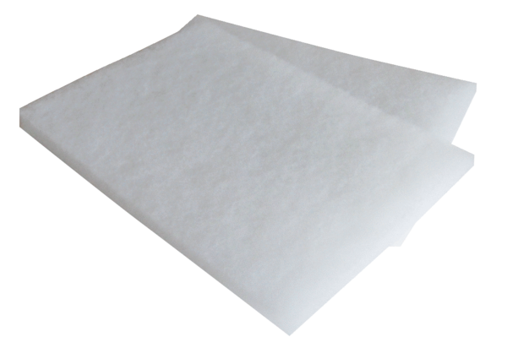Air filter, replacement WSG 150Packing unit: 2 piecesRange: K
Article number: 0093.0892Manufacturer: MAICO

