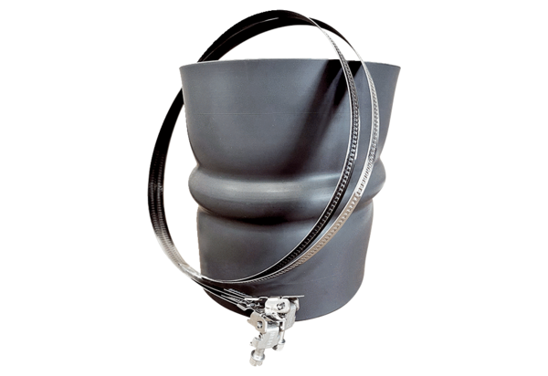Flexible cuff STKI 28Packing unit: 1 pieceRange: C
Article number: 0073.0490Manufacturer: MAICO

