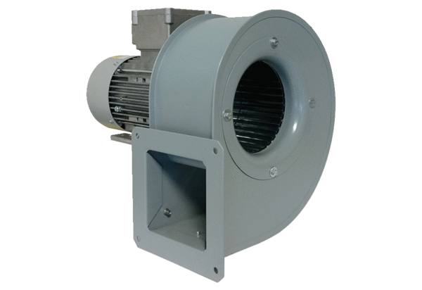Centrifugal blower GRM 10/2 E ExPacking unit: 1 pieceRange: C
Article number: 0073.0383Manufacturer: MAICO

