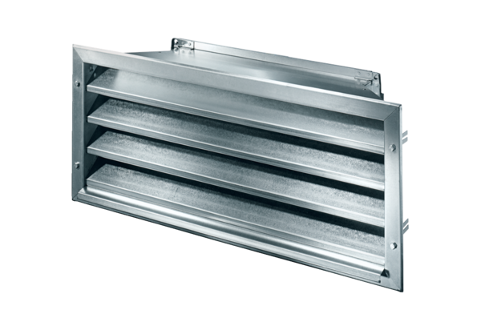External grille LZP-R 93Packing unit: 1 pieceRange: D
Article number: 0151.0388Manufacturer: MAICO

