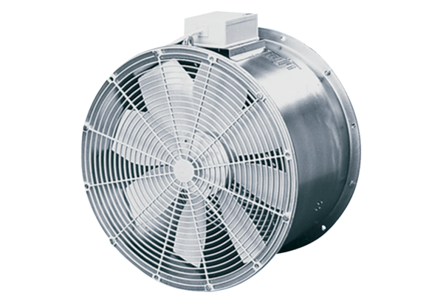Axial greenhouse fan EZG 35/4 BPacking unit: 1 pieceRange: C
Article number: 0085.0151Manufacturer: MAICO

