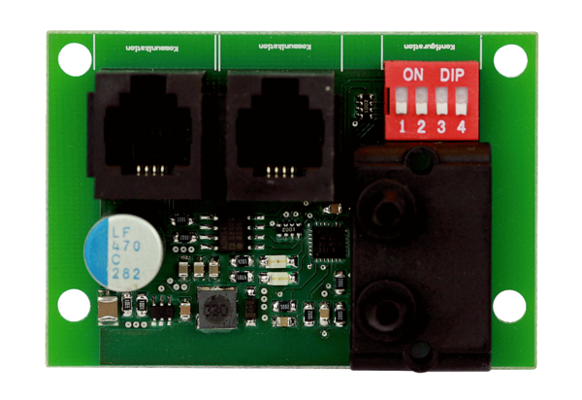Additional circuit board ZP 2Packing unit: 1 pieceRange: K
Article number: 0092.0555Manufacturer: MAICO

