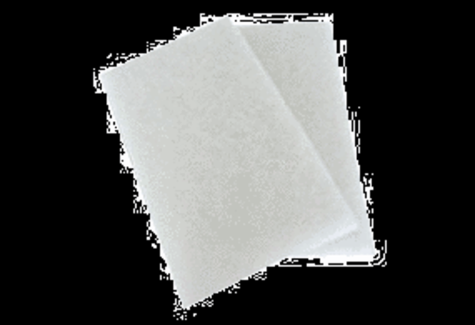Air filter, replacement WRF 300 ECPacking unit: 2 x G4Range: K
Article number: 0093.0061_altManufacturer: MAICO

