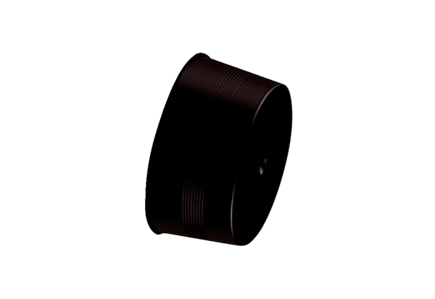Sealing cover MA-VD90Packing unit: 10 piecesRange: K
Article number: 0059.2139Manufacturer: MAICO

