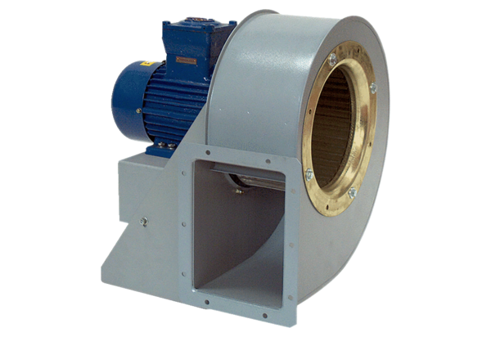Centrifugal blower GRM HD 25/6 ExPacking unit: 1 pieceRange: C
Article number: 0073.0402Manufacturer: MAICO

